Senegal Hunger Story Review

Progress and general stats:
- Prevalence of Undernourishment
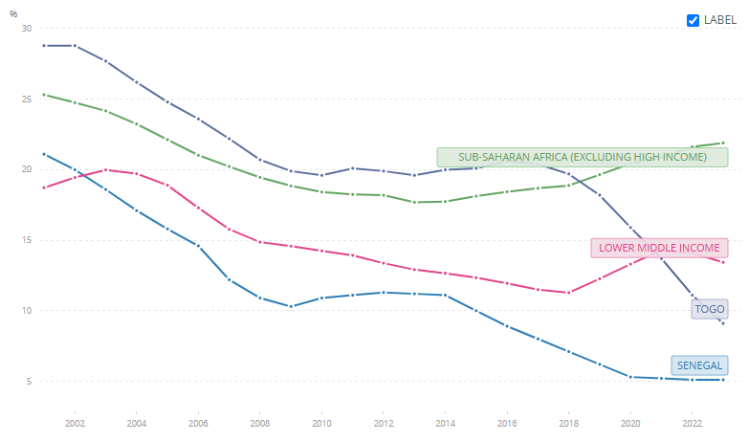
- Cereal Yield
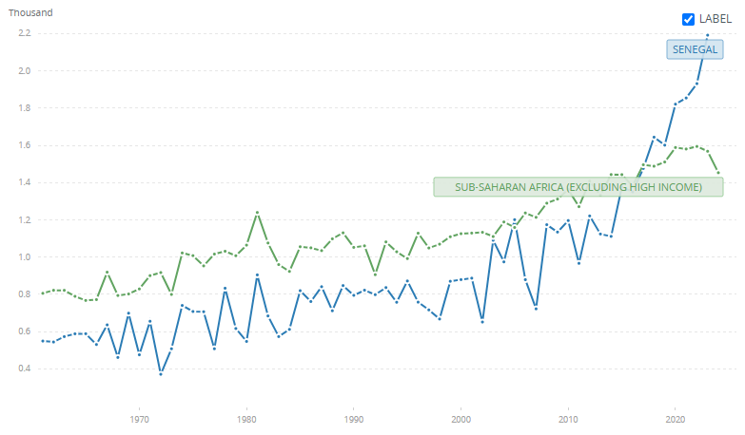
- Aggregate cereal yield, including millet, sorghum, maize, and rice, was essentially flat and highly volatile through the 1985–2000 period, oscillating around 795–872 kg/ha.” (WDI)
- First structural shift occurred around 2003–2005, pushing yields into the 1,000–1,200 kg/ha range (Databank)
- 2023 figure is roughly 2.75 times the 1990 level
- “In 2024, Togo recorded a record cereal production of 1.5 million tons, against a backdrop of steady growth since 2019, while poultry numbers topped 38 million, and fish farming rose from just 20 tons in 2011 to 1,300 tons. With UN support, over 15,000 producers and 10,000 vulnerable farming households, more than half led by women, grew their yields through training, digital advisory tools in local languages, and stronger value chains.” (UN DCO)

Political Stability and Long-Term Policy Continuity
- Maintained uninterrupted civilian governance and peaceful transitions of power across the entire period of hunger decline. (Brookings Institute)
  - Stability allowed successive agricultural and food security programmes to compound rather than be interrupted.
  - Policy frameworks were revised and built upon, REVA (2006), GOANA (2008), and then PRACAS (2014) under the broader Plan Sénégal Émergent (PSE)
Agricultural Productivity and Cereal Yield Growth
- Aggregate cereal yields rose from ~1,000–1,200 kg/ha (2005–2014) to 2,192 kg/ha in 2023, a near-doubling in under ten years (WDI)
- Paddy rice production increased from 551,000 tons in 2014 to over 1.5 million tons in 2023, driven by improved seeds, irrigation rehabilitation, and modernized equipment — though Senegal continues to import around 44% of annual rice demand
- Driven primarily by improved seed varieties (millet and rice), the Program for the Accelerated Pace of Senegalese Agriculture (PRACAS) (2014), and the World Bank's WAAPP, which reached ~500,000 farmers ([3])
- PARIIS project aimed to build better water and irrigation tools in certain areas was extremely effective
Nutrition Governance - CLM/CNDN
Senegal established the Cellule de Lutte contre la Malnutrition (CLM), housed in the Prime Minister's Office, as a multisectoral coordination body integrating health, education, water, sanitation, and agriculture ministries, a governance structure credited as central to the country's stunting success
- Two flagship community programs — the Community Nutrition Program and the Nutrition Enhancement Program (PRN) — delivered growth monitoring, supplementary feeding, and caregiver education at community level at scale
- Between 1992 and 2014, Senegal reduced stunting by 46% (from 34.4% to 19.4%), positioning it as a model for Francophone Sub-Saharan Africa (Exemplars in Global Health)
World Bank Early Childhood — Investing in Early Years Project
- The World Bank's Investing in Early Years for Human Development Project (approved 2018) directly targeted high stunting rates, low preschool enrollment, and incomplete birth registration through an integrated nutrition and education approach (World Bank Results Brief, April 2024)
- 14 million mothers and children in Senegal benefited from early childhood interventions including essential nutrition services
- Over 10 million children aged 0–23 months in targeted regions received nutrition and early stimulation interventions; early stimulation rate reached 72%, surpassing the target of 65%
- Over 1.4 million children aged 6–59 months were screened for acute malnutrition
- Over 4,593 Growth Monitoring and Promotion (GMP) sites were operationalized, with 83% delivering the full integrated package
- Stunting declined from 21% to 18% between 2015 and 2019 in project-covered areas
- Preschool enrollment for children aged 3–5 rose from 9.8% to 18.3%, exceeding the 18% target
- Birth registration increased from 43% to 73% between 2018 and 2023
- 3,517 preschool teachers were trained, nearly doubling the target of 1,800
- 9,610 community volunteers were trained and deployed; 900 religious leaders helped advocate for parental involvement in early childhood development through the National Nutrition Enhancement Program
Health, Water, and Sanitation
- 2017 SMART survey found 13.9% of children in Senegal underweight; more than 1 in 5 women of childbearing age are underweight — indicating nutrition deficits extend well beyond childhood (Action Contre la Faim)
- Repeated diarrheal infections impair nutrient absorption even when dietary intake is adequate; the 8.1% of stunting reduction attributed to piped water access likely understates total sanitation impact when open defecation rates and disease burden are included (Headey et al., 2020)
- Helen Keller International, in collaboration with Senegal's Ministry of Health, piloted a community-based model to decentralize screening, treatment, and monitoring of severe acute malnutrition to local health clinics
WFP School Feeding and Targeted Transfers
- WFP operates school feeding programs and provides specialized nutritious food for acutely malnourished children and pregnant or lactating women, functioning as a critical protective floor during lean seasons and climate shocks (WFP Senegal 2024 Annual Country Report)
- These programs do not operate at the scale needed to explain aggregate national trends, but target populations that would otherwise slip into severe acute malnutrition during seasonal peaks
- The National Agricultural Insurance Company (CNAAS) and rural financial resilience schemes aim to reduce household-level food crisis severity, though penetration remains limited in the most food-insecure zones
Factors with Limited Aggregate Impact
- Rainfall and climate variability: Explains year-to-year fluctuations in acute food insecurity (lean season caseload fell from 1.26 million in 2023 to 518,500 in 2024 largely because rains improved) but does not explain the downward trend in undernourishment; improved technology and governance have progressively reduced rainfall shock transmission into sustained hunger
- Irrigation expansion: Covers less than 1% of agricultural land nationally; productive within the Senegal River Valley but too small in aggregate share to drive national trends
- Fisheries and livestock: Contribute to dietary diversity and rural income but are not a primary driver of undernourishment trends; overfishing pressure and feed cost shocks create volatility that partially offsets gains
- Dietary diversification: Remains deeply unresolved, 93% of young children do not receive a minimum acceptable diet; 64% of infants are not exclusively breastfed, a dimension of malnutrition the undernourishment headline indicator does not capture (WFP 2024)

